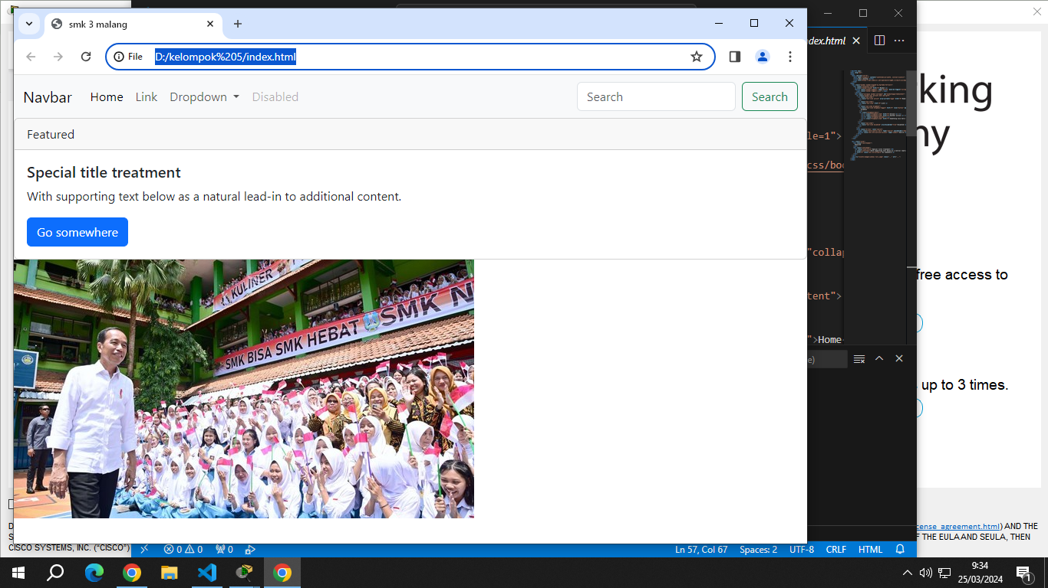

KELOMPOK 5
-BAGAS ARISTYANTO/5
-VIGO DAMAR ROSANDI/35
-RENDRA GILANG PRAYOGHA/31
-LUCKY RAGIL PRAYOGA/15
-EZHAR MAULANA KAUTSAR/9

